

RESOURCES – WORKBOOK
COMPUTER NETWORK
student nAME: Tiwouw, joseph janone
inSTRuctor: Jimmy MoedjaHEDY
Universitas Klabat
airmadidi-minahasa utara
Version 1.6

RESOURCES – WORKBOOK
COMPUTER NETWORK

wINDOWS SERVER 2012

Goal
- Configure IIS Web Server

List of activity

Activities
Add IIS web server through Server Manager
Drive C→ inetpub → wwwroot, will be your place to put all your web files and folders
Make sure change your Network configuration to host-only (virtual box) so you can access your web server through another machine (host)
Check if your IIS service, make sure the service is start (Administrative tools → IIS)
Make index.html file the content is your full name
Put the file in wwwroot
Try to access your web using IP, localhost, from your browser
Try to access your web from another machine
Capture all your activities
Put index.html on another folder/directory named “sub”
Try those process using different web server (apache) https://www.appserv.org/en/

Answer sheet for a. Configure IIS web server

2. membuka file yang sudah ditentukan di modul 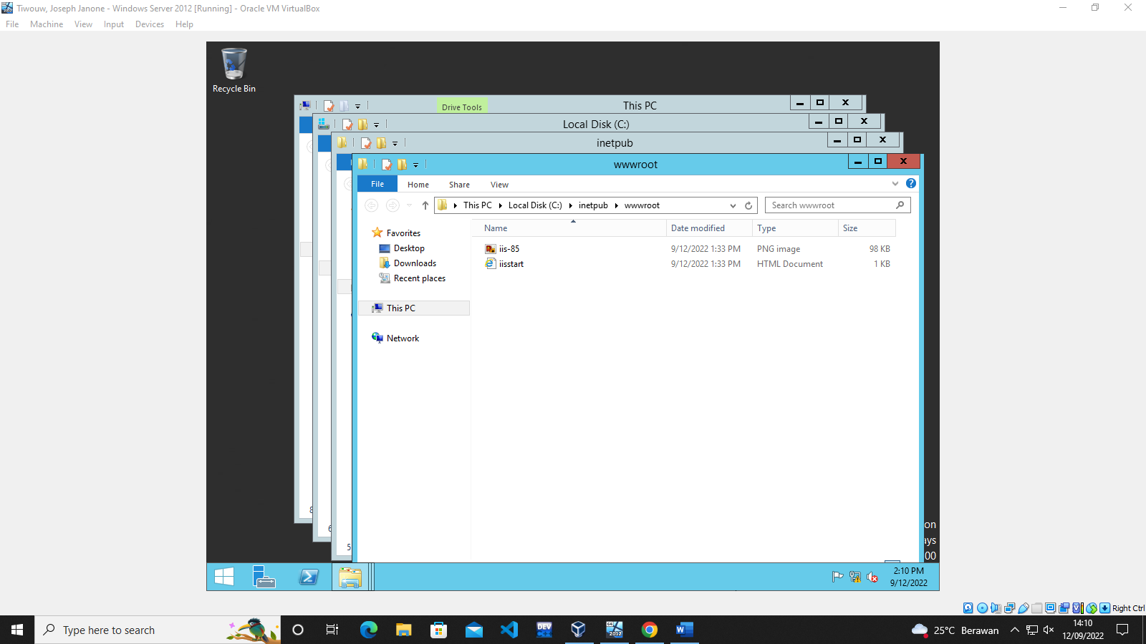
3. memastikan config network host-only agar bisa mengakses web server dari virtual machine lain
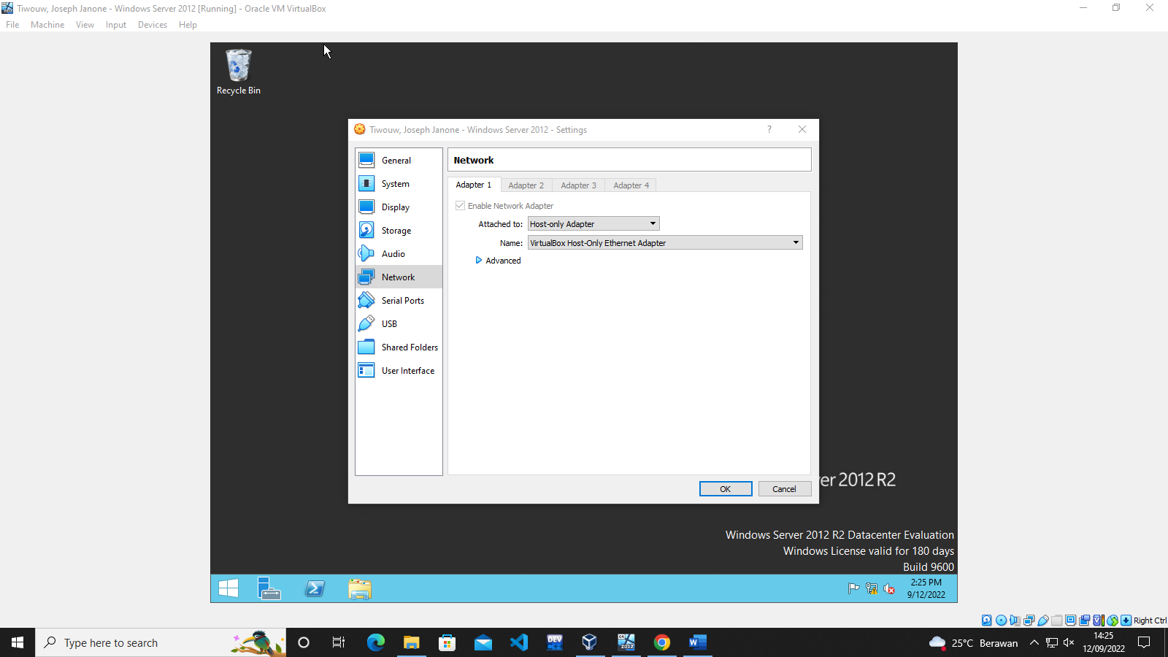

5. membuat file html dengan yang berisi nama lengkap
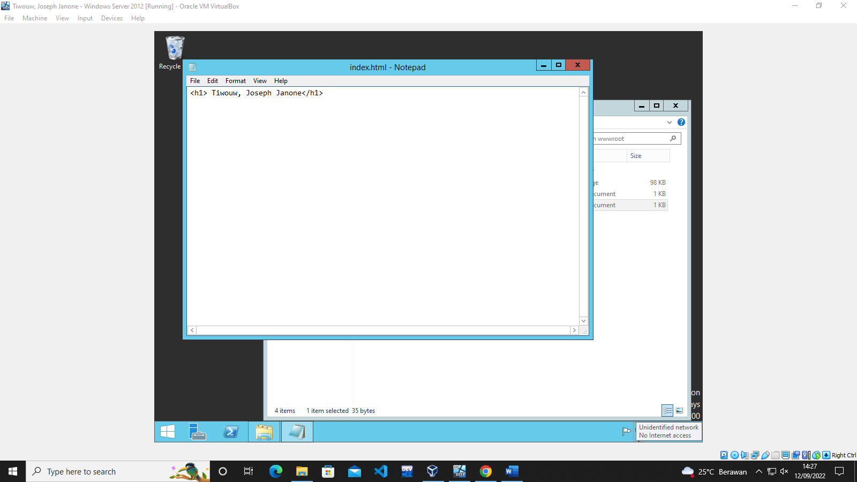
6. letakkan file pada folder wwwroot
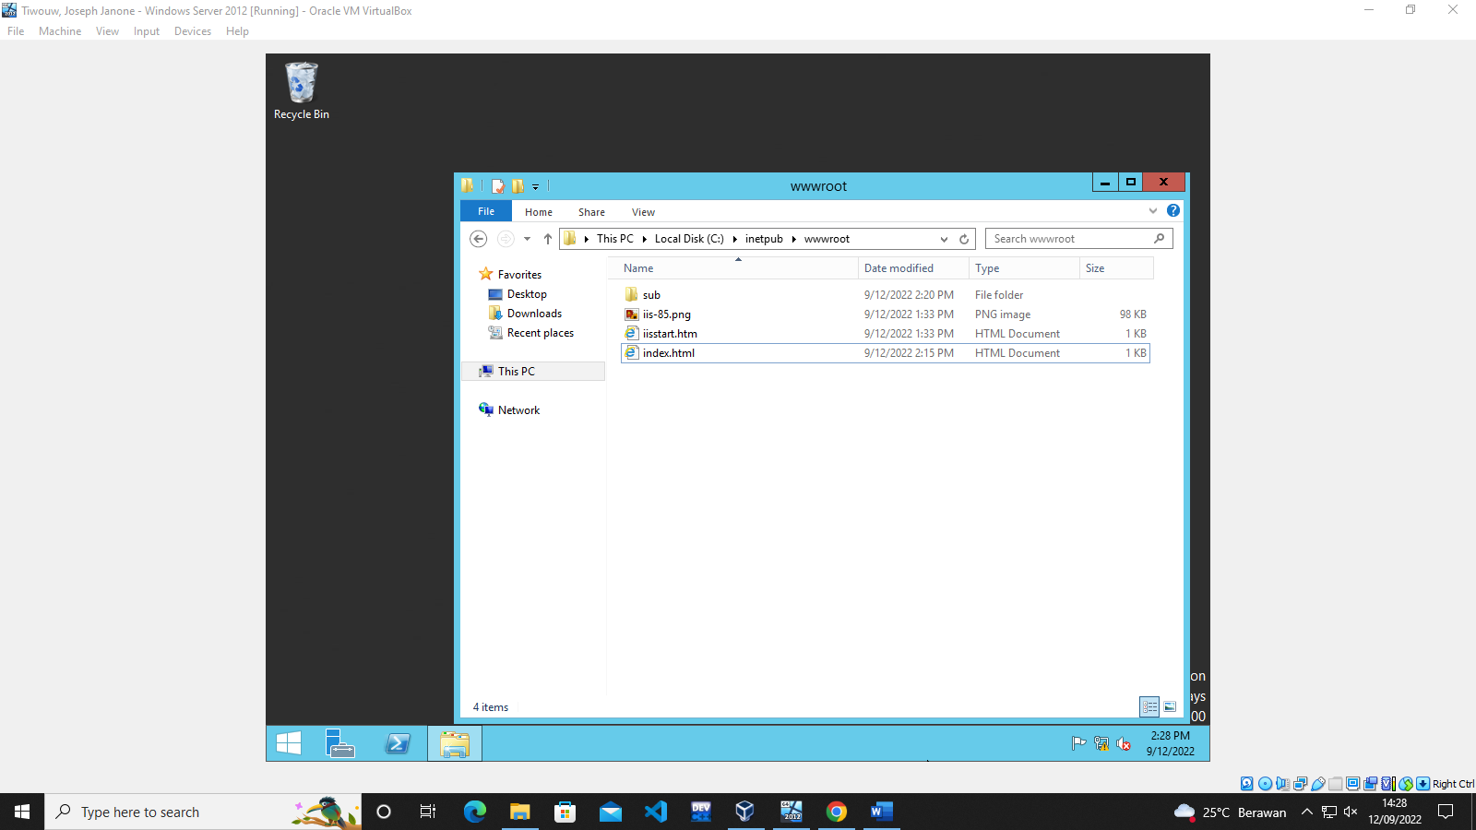

7. mencoba mengakses web dari browser
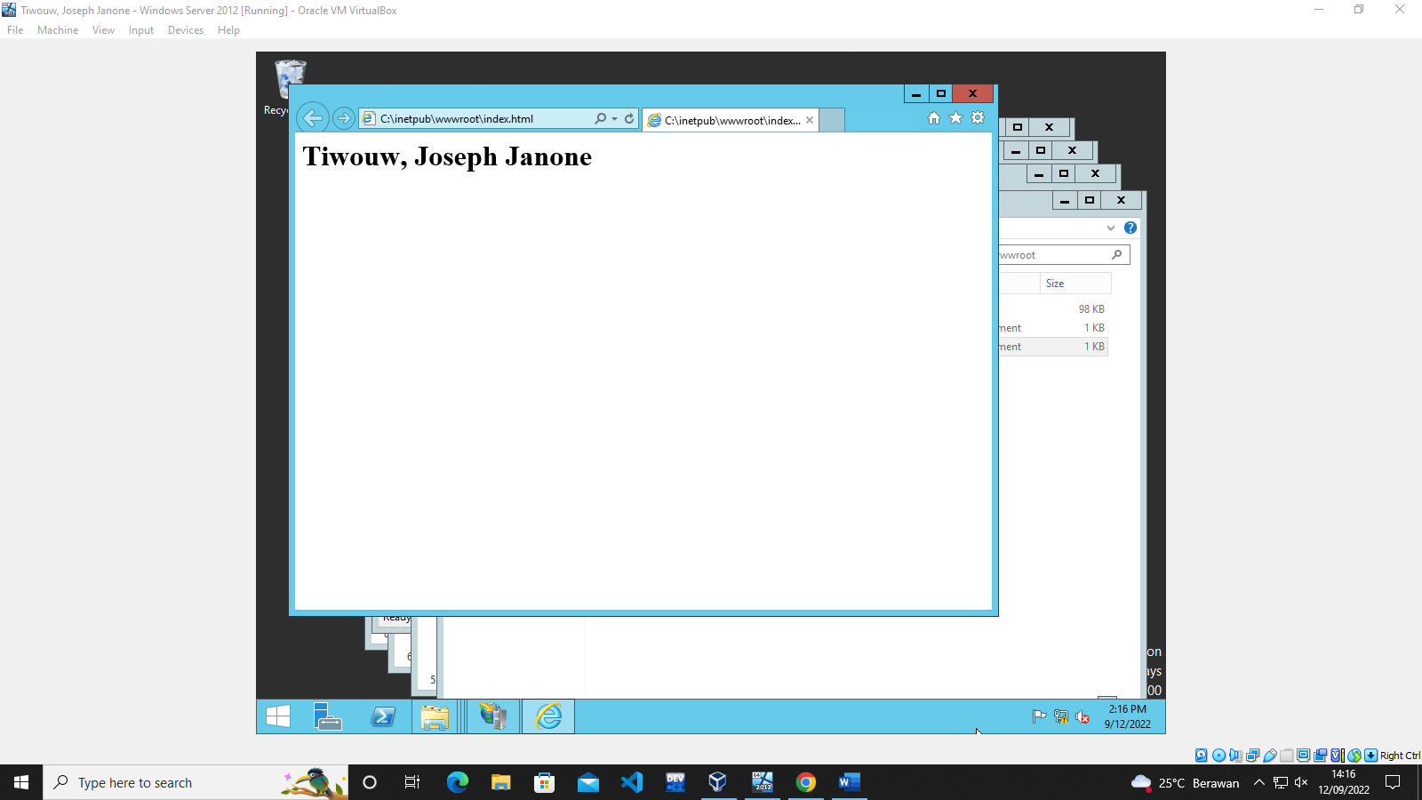
8. mencoba mengakses web dari virtual machine lain


10. meletakkan file index.html ke folder lain dengan nama sub
